**Experiment 29**

**AIM:** To identify and monitor ip,network address,router information,node connection.

**Requirements:**

Ip scanner

Router requirements software.

Network connected to broadband connection.

**Procedure:**

* Firstly install ip scanner software in system or laptop.
* Then according with the ip address we enter in the window.
* Observing the ip packets below the given addresses gives the complete information of the mobility of packets.
* Click on the play button to observe the transmission of ip packets as well as network addresses.

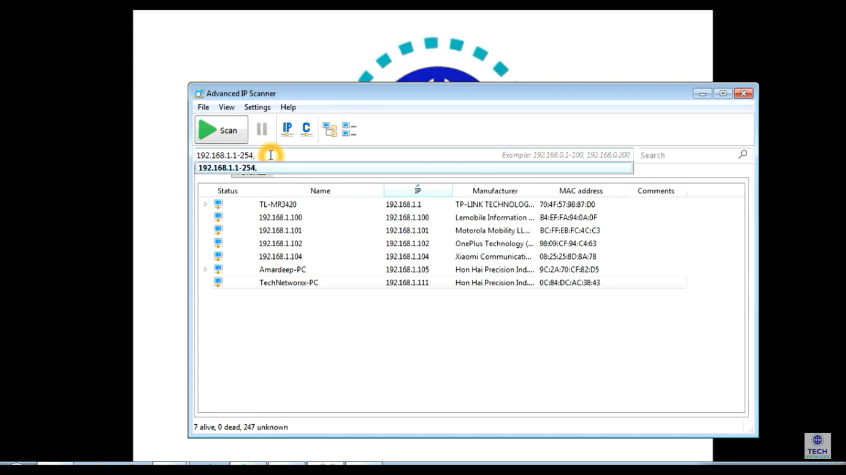

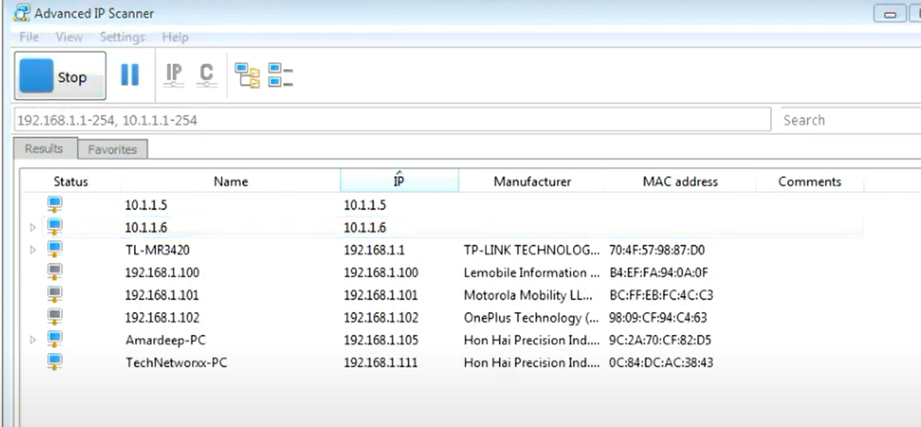

**Result:** Thus to identify and monitor ip,network address,router information,node connection is done and verified successfully.